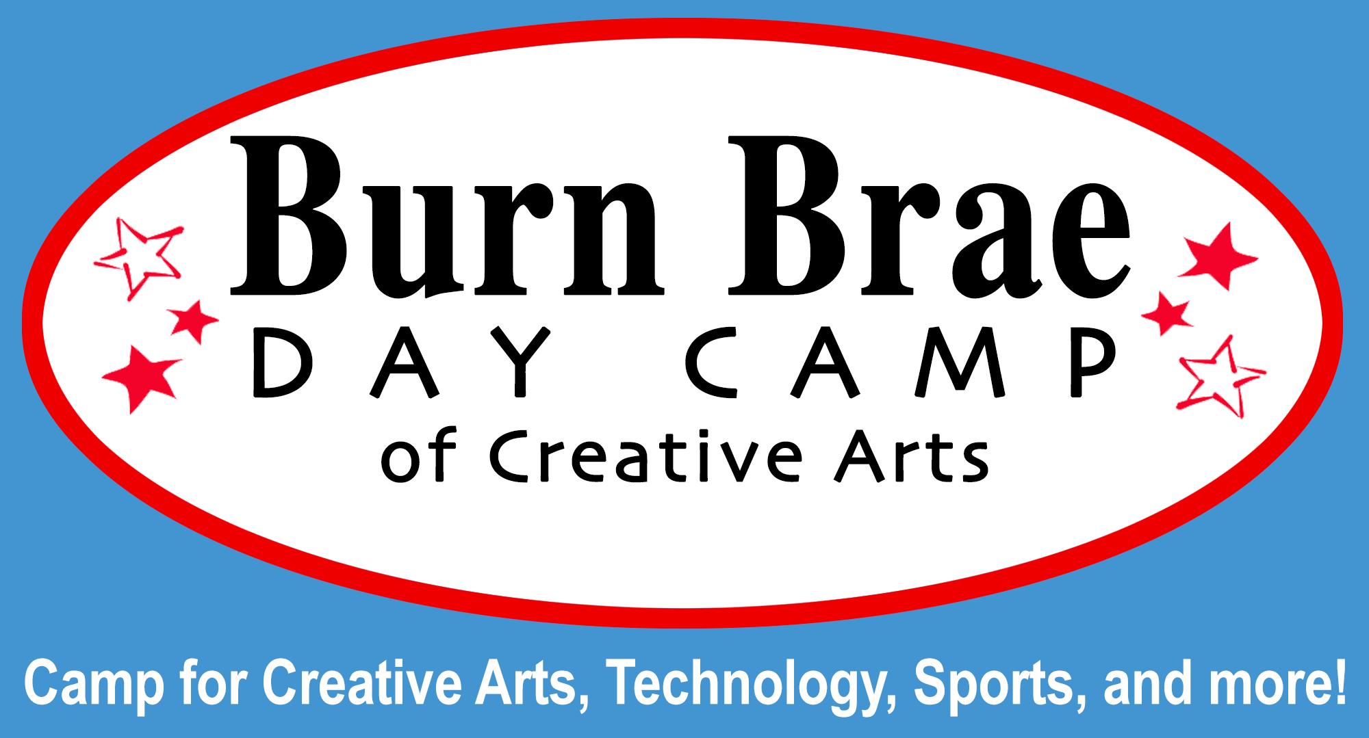
This Spring!
Archery!!
- Ages 7+ –
Each Child session $15
Parent/Child session $20

Are you new to Archery?
or
Have you experienced Archery and want more opportunities to use a bow and arrow?

Come join us for a favorite Burn Brae Day Camp activity with our professional archery teacher - Anne Margaret O’Malley!
2016 ARCHERY Sessions
at Burn Brae Day Camp!!

Child Drop-Off Sessions (drop-ins welcome)
Sundays: April 17th, April 24th, May 22nd
Hours: 1:00 to 2:00 pm or 2:00 – 3:00 pm

Parent and Child Sessions
Saturday: May 21st
Hours: 3:00 – 4:00 pm

Ask about our Archery birthday parties!!

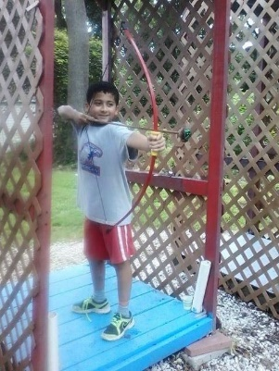

Equipment provided.
Questions? Call 215-657-3388 or burnbraedaycamp@aol.com
Make checks payable to “Burn Brae Day Camp” and mail to: Burn Brae 1405 Twining Rd, Dresher, PA 19025 or call with a credit card
Child Only Session(s) 2:00 – 3:00:
(Sundays)
April 17th ____ $15
April 24th ____ $15
May 22th ____ $15

Parent/Child Session 2:00 – 3:00:
(Saturday)

May 21st

___
$20

Child Only Session(s) 1:00 – 2:00:
(Sundays)
April 17th ____ $15
April 24th ____ $15
May 22th ____ $15

Burn Brae Day Camp - ARCHERY Enrollment Application Spring 2016

Child’s Name: __________________________________________ Boy____ Girl____
Child’s Birthdate: ________________________________________ Grade: ____________
Street Address: _________________________________________ School: ________________________________
City/State/Zip: __________________________________________ Home Phone: ____________________________
Parents’/Guardians’ Name: ________________________________ Email Address: ___________________________
Parents’ Cell Phone(s): _______________________________________________________________________________
Emergency Contact Name and Number: __________________________________________________________________

