2017 Spring!
1405 Twining Road, Dresher PA 19025
215-657-3388
burnbraedaycamp@aol.com
www.burnbraedaycamp.com

Archery!!
- Ages 7 through Teens –
Each session $15
All 7 sessions for $105

Are you new to Archery?
or
Have you experienced Archery and want more opportunities to use a bow and arrow?

Come join us for a favorite Burn Brae Day Camp activity with our professional archery teacher – Anne Margaret!
2017 ARCHERY Sessions
at Burn Brae Day Camp!!

Archery Sessions
7 Sundays:
- April 9, 23, 30
- May 7, 21, 28
- June 4 (parents invited to participate for the last 30 minutes on this date)
Hours: 1:00 to 2:00 pm or 2:00 to 3:00 pm
Ask about our Archery birthday parties, our summer camp archery program and scout archery workshops!!

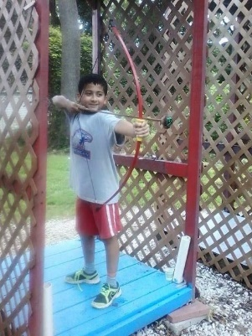
Equipment provided.
Questions? Call 215-657-3388 or burnbraedaycamp@aol.com
Make checks payable to “Burn Brae Day Camp” and mail to: Burn Brae 1405 Twining Rd, Dresher, PA 19025 or call with a credit card. REGISTER ONLINE! http://www.burnbraedaycamp.com/archery-in-spring
2:00 – 3:00 Session(s) $15 each class (Sundays):
April 9th ____ May 7th ____ June 4th ____
April 23rd ____ May 21st ____
April 30th ____ May 28th ____

1:00 – 2:00 Session(s) $15 each class (Sundays):
April 9th ____ May 7th ____ June 4th ____
April 23rd ____ May 21st ____
April 30th ____ May 28th ____

Burn Brae Day Camp - ARCHERY Enrollment Application Spring 2017
Child’s Name: __________________________________________ Boy____ Girl____
Child’s Birthdate: ________________________________________ Grade: ____________
Street Address: _________________________________________ School: ________________________________
City/State/Zip: __________________________________________ Home Phone: ____________________________
Parents’/Guardians’ Name: ________________________________ Email Address: ___________________________
Parents’ Cell Phone(s): _______________________________________________________________________________
Emergency Contact Name and Number: __________________________________________________________________

