WINTER!
Rock Band Jam!!
For Vocalists and/or Instrumentalists
1405 Twining Road, Dresher PA 19025
215-657-3388
www.burnbraedaycamp.com
- Ages 7 to 15 –
All levels of students in the community are welcome… from beginner to experienced!

Come join us for a favorite Burn Brae Day Camp activity with our long-time, professional Rock Band teacher/performer/composer –
Jay Klales

Students will have a Rock Band performance for family and friends
on March 11 at 4:00 pm
2017 WINTER ROCK BAND
Sessions at Burn Brae Day Camp!!
3:00 to 4:30 PM
9 SATURDAYS for only $145:
Jan. 14
Jan. 21
Jan. 28
Feb. 4
Feb. 11
Feb. 18
Feb. 25
March 4
March 11
(performance at 4:00 pm on March 11)
*If a class is cancelled due to weather, it will be rescheduled.

Hours: 3:00 – 4:30
(In our indoor facility)

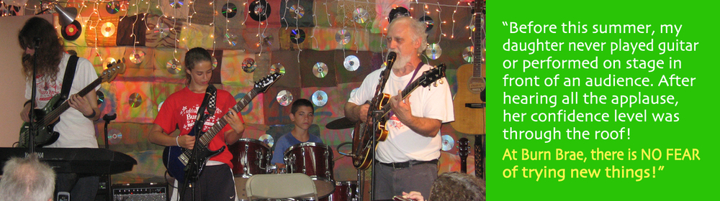

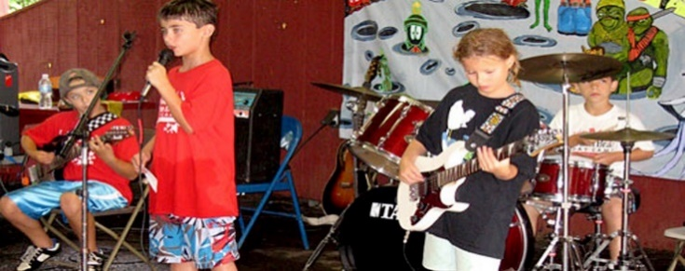

Instrument to be supplied by child – except drums and keyboard.
Questions? Call 215-657-3388 or burnbraedaycamp@aol.com
Make checks payable to “Burn Brae Day Camp” and mail to: Burn Brae 1405 Twining Rd, Dresher, PA 19025
or call with a credit card. REGISTER ONLINE! http://www.burnbraedaycamp.com/rock-band-jam-saturdays/
Burn Brae Day Camp – ROCK BAND JAM Enrollment Application WINTER 2017
(Check one:) Vocal____ Instrument____ Type of Instrument: ____________________________________
Skill Level: ___________________________________________
Child’s Name: ___________________________________________ Boy____ Girl____
Child’s Birthdate: _________________________________________ Grade: ____________
Street Address: __________________________________________ School: _________________________________
City/State/Zip: ___________________________________________ Email Address: ___________________________
Medical Concerns/Food Allergies: ______________________________________________________________________
Parents’/Guardians’ Name: _________________________________ Home Phone: ____________________________
Parents’ Cell Phone(s): _______________________________________________________________________________
Emergency Contact Name and Number: _________________________________________________________________

